

Programming Fundamentals
PBL

REPORT OF FINAL PROJECT

Supermarket Billing System Report
- Project Overview
This is a simple implementation of the Supermarket Billing System, written in C++. It allows two primary types of users:
Salesman: They can manage products, view sales, and update prices/discounts.
Customer: They can browse through products, purchase items, and see a total bill with discounts.
The system enables a salesman to log in with a password and update the product catalog - add, update, or print out products. Available products are displayed to a customer who can buy something and be given a detailed bill. The sales are registered for tracing purposes, while the amount of purchase money is computed with discount inclusions.
Features and Functionality
1. System Initialization and Data Setup
Product Initialization: In the start, the program initializes a few sample products:
Apple: Price = 1.5, Discount = 10%
Banana: Price = 0.5, Discount = 5%
Orange: Price = 2.0, Discount = 15%
These products are stored in an array and can be managed by the salesman.
2. Salesman Functions
Authenticate Salesman:
The salesman needs to enter a password to access the menu. The password is pre-defined as admin123.
Product Management:
Add Product: A salesman is enabled to fill in information ID, name, price, discount, and add the new product into the list. It's possible because of MAX_PRODUCTS (is 100 by default), which restricts this operation.
Update Product: A salesman is enabled to update price and discount for the existed product according to its ID.
Show Products: Displays all available products including their ID, name, price, and discount.
Display Sales: Displays a list of all logged sales, product ID, name, quantity sold, and total price.
3. Customer Functions
View and Buy Products:
The customer can view all the available products and add them to their shopping cart by providing the product ID and quantity.
Price Calculation: A discount is applied to the price of each product, and the final price is calculated as:
Final Price=Price−(Discount Percentage/100​×Price)
The total amount is updated after every purchase, and the detailed summary is displayed at the end.
4. Sales Log
Every sale made by the customer is logged with:
Product ID
Product Name
Quantity Purchased
Total Price for that product (after discount)
The sales log is kept with a limit of MAX_SALES, which is set to 100 sales.
Code Structure
Data Structures
Product Structure:
Each product is represented by id, name, price, and discount.
Used to store product data and the product list.
Sale Structure:
Represents a sale with id, name, quantity, and totalPrice.
Used to store all the sale records of bought products.
Global Variables:
products[]: Array of Product structures holding the product list.
salesLog[]: Array of Sale structures holding all the sales data.
productCount: number holding the count of products in the list.
salesCount: number holding the count of sales logged.
Main Functions
initializeProducts(): Initialize the product catalog with three predefined products.
findProductIndex(int id): Searches for a product in the catalog by its ID and returns the index if found, or -1 if not found.

addProduct(): The salesman is able to add a new product in the catalog.
updateProduct(): The salesman can update an existing product's price and discount.
displayProducts(): Display all the products with their details.
buyProducts(): Enables the customer to make purchases. It computes the subtotal with discounts.
displaySales(): Prints all sales.
authenticateSalesman(): Authenticates the salesman's password, then allows him to the salesman menu.
salesmanMenu(): Presents choices for a salesman to maintain products, as well as print sales histories.
customerMenu(): It presents choices for a customer to buy products and end.
Main Program Flow
The program begins with the welcome message and pre-initialized products.
A loop in the main() function allows users to choose between accessing the salesman or customer menu.
Salesman: Needs to authenticate via password. If correct, access to the product management and sales logging features is granted.
Customer: Can directly access the menu to buy products.
The program ends when the user selects the "Exit" option.
System Limitations and Improvements
Product and Sales Limits: The system has the limitation of the number of products (MAX_PRODUCTS) and sales (MAX_SALES) that is hardcoded to increase for scalability.
Password Security: The password is maintained in plain text. Instead, a secure system should contain encrypted password storage along with multi-factor authentication.
Error Handling: The program does basic error handling, checking for an invalid product ID and quantity, but the input validation could be better.
Sales Reports: While the system logs sales, it doesn't provide the ability to create advanced reports, such as total sales for a period, most popular products, etc. That is something that might be developed later.

OUTPUT:
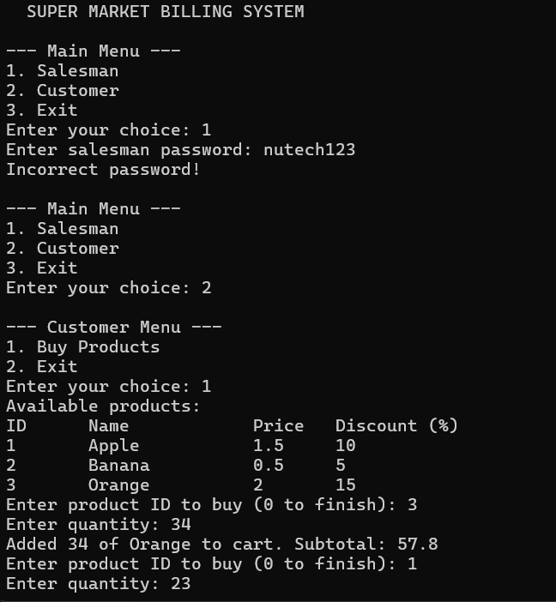
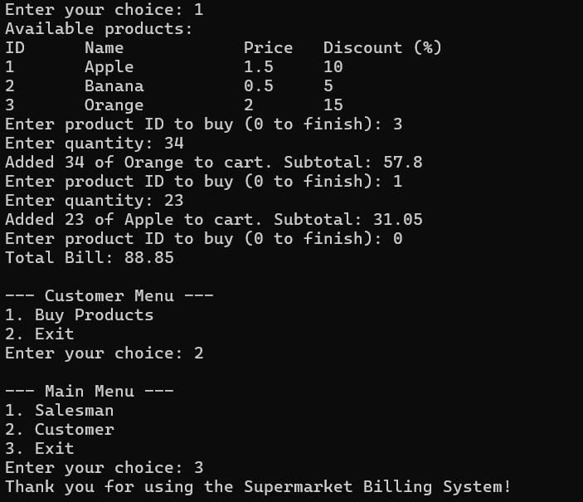
Conclusion:
This Supermarket Billing System provides a basic, functional implementation for managing products as well as processing customer purchases. It is useful for small-scale supermarkets in tracking the inventory and sales of their products in a simplified manner. Adding/updating product functionalities along with calculating the bill amount after applying discount and logging the sales assist in smoothing the operations and providing an efficient way to manage transactions.

